PortSwigger Web Security Academy — Proof of Concept

CSRF Lab 5

CSRF where token is tied to non-session cookie
Category | CSRF
Lab | Lab 5
Completed By | Security Researcher
Platform | PortSwigger Web Security Academy

Lab Objective
Exploit a CSRF token that is tied to a non-session cookie and inject the cookie via search functionality.

Step-by-Step Exploitation
- Open Burp's browser and log in to your account. Submit the "Update email" form, and find the resulting request in your Proxy history.
- Send the request to Burp Repeater and observe that changing the session cookie logs you out, but changing the csrfKey cookie merely results in the CSRF token being rejected. This suggests that the csrfKey cookie may not be strictly tied to the session.
- Open a private/incognito browser window, log in to your other account, and send a fresh update email request into Burp Repeater.
- Observe that if you swap the csrfKey cookie and csrf parameter from the first account to the second account, the request is accepted.
- Close the Repeater tab and incognito browser.
- Back in the original browser, perform a search, send the resulting request to Burp Repeater, and observe that the search term gets reflected in the Set-Cookie header. Since the search function has no CSRF protection, you can use this to inject cookies into the victim user's browser.
- Create a URL that uses this vulnerability to inject your csrfKey cookie into the victim's browser:
- /?search=test%0d%0aSet-Cookie:%20csrfKey=YOUR-KEY%3b%20SameSite=None
- Create and host a proof of concept exploit as described in the solution to the CSRF vulnerability with no defenses lab, ensuring that you include your CSRF token. The exploit should be created from the email change request.
- Remove the auto-submit <script> block, and instead add the following code to inject the cookie:
<img src="https://YOUR-LAB-ID.web-security-academy.net/?search=test%0d%0aSet-Cookie:%20csrfKey=YOUR-KEY%3b%20SameSite=None" onerror="document.forms[0].submit()">
- Change the email address in your exploit so that it doesn't match your own.
- Store the exploit, then click "Deliver to victim" to solve the lab.

Screenshots & Evidence
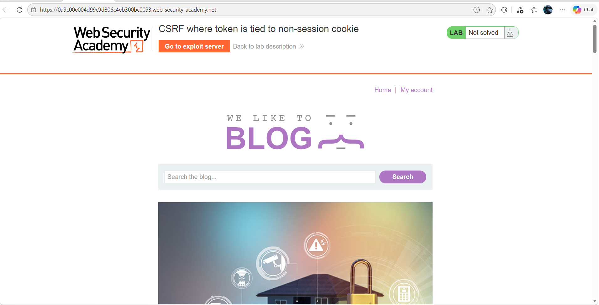
Figure 1: 1st Home Image
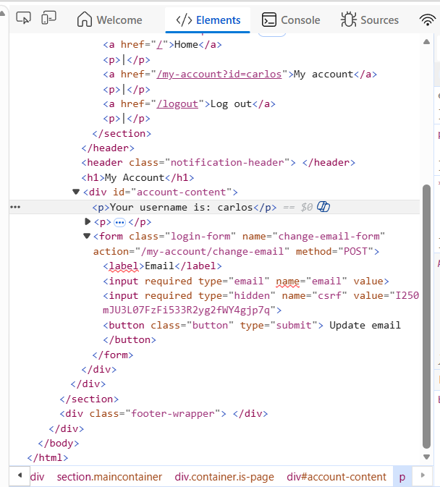
Figure 2: Carlos Csrf Token
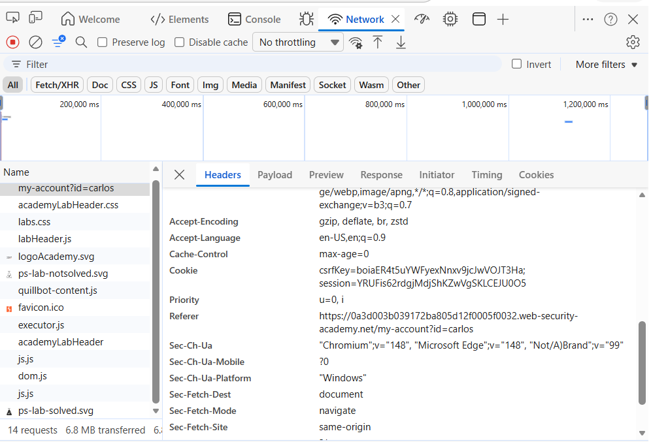
Figure 3: Carlso Csrf Key
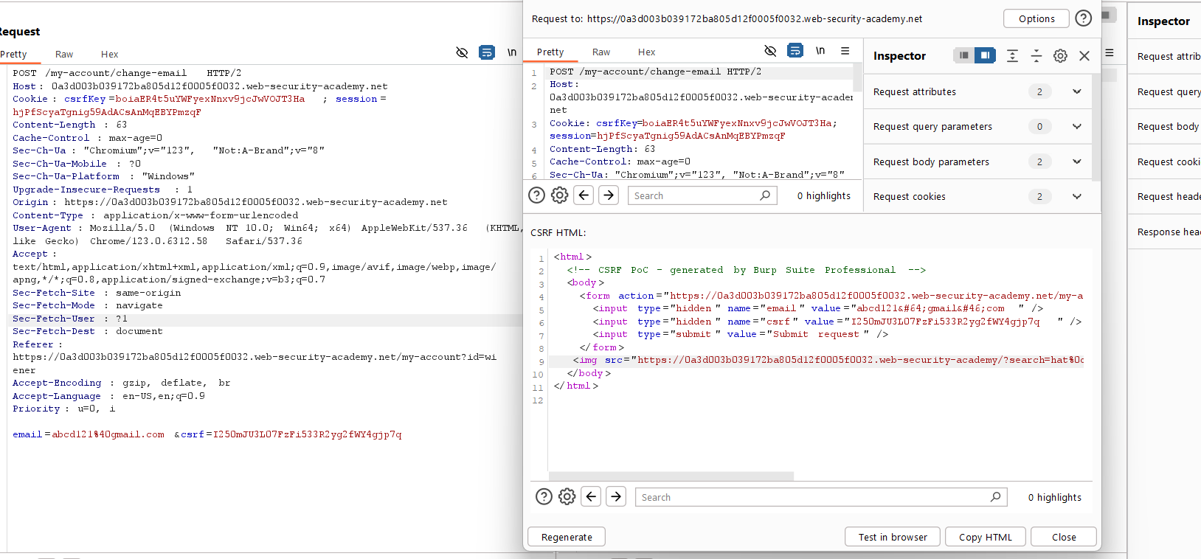
Figure 4: Generate The Poc Of Csrf With Edit The Submit Button To Img Scr Url Past
Lab Solved — Confirmation
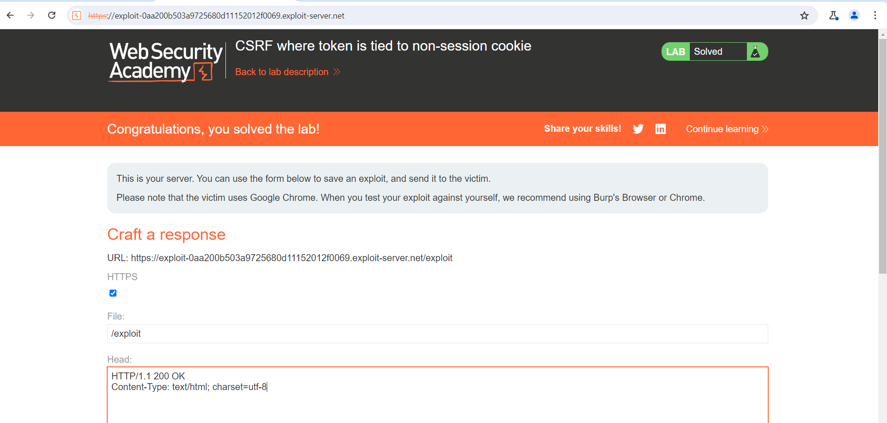
Figure 5: Lab Solved
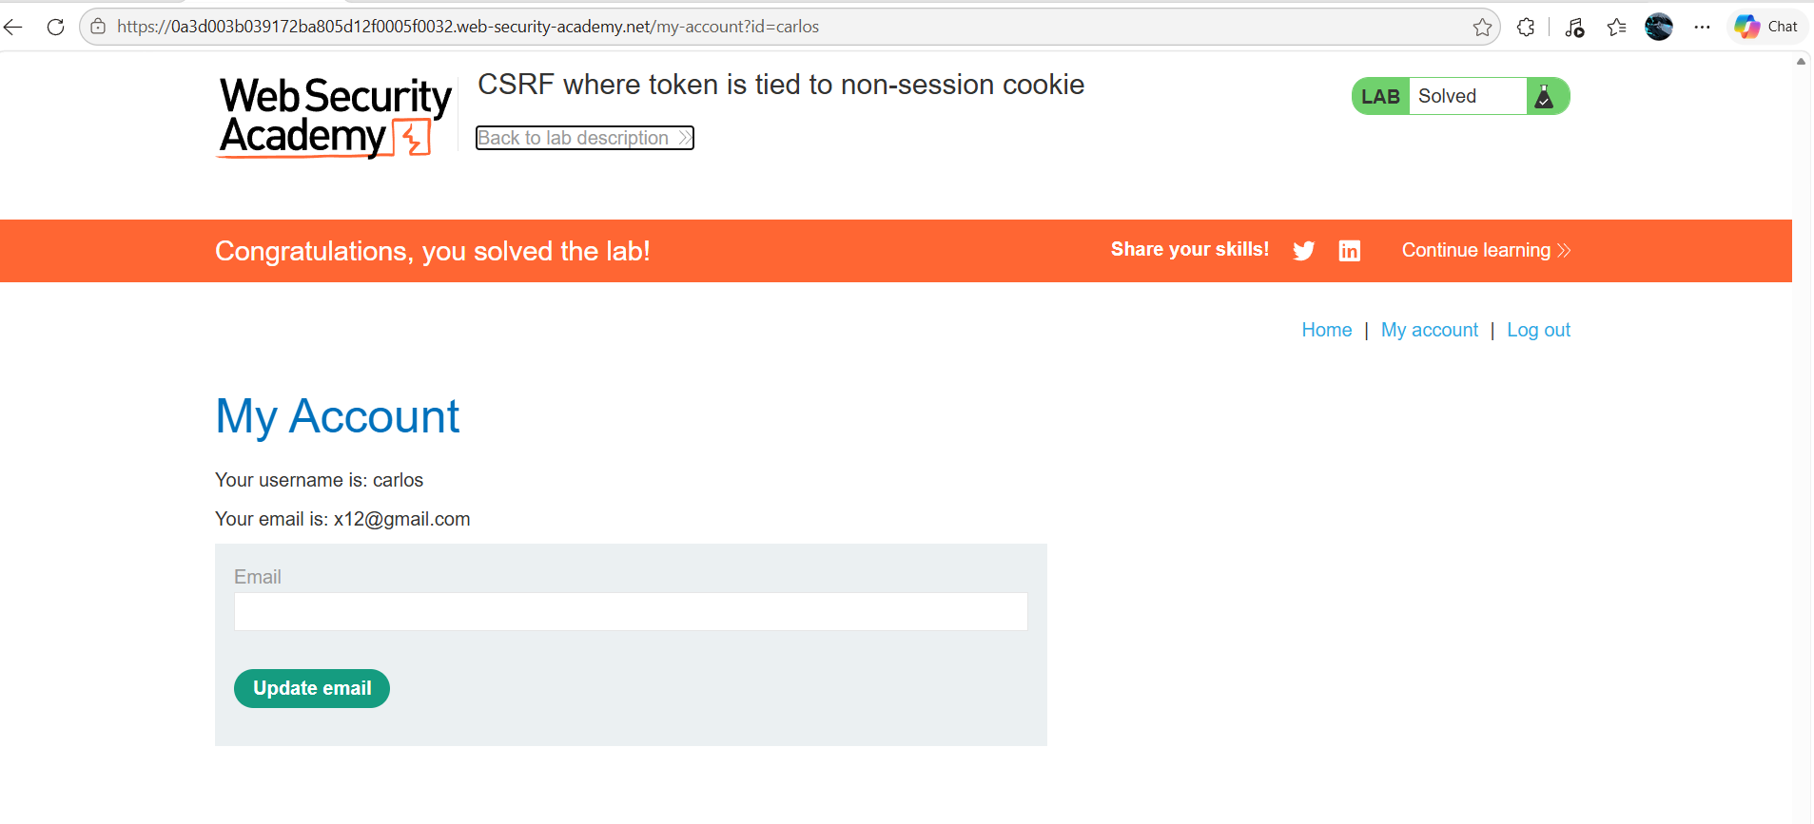
Figure 6: Login The Carlso Account Another Browser And And Inspect For Csrf Token And Key
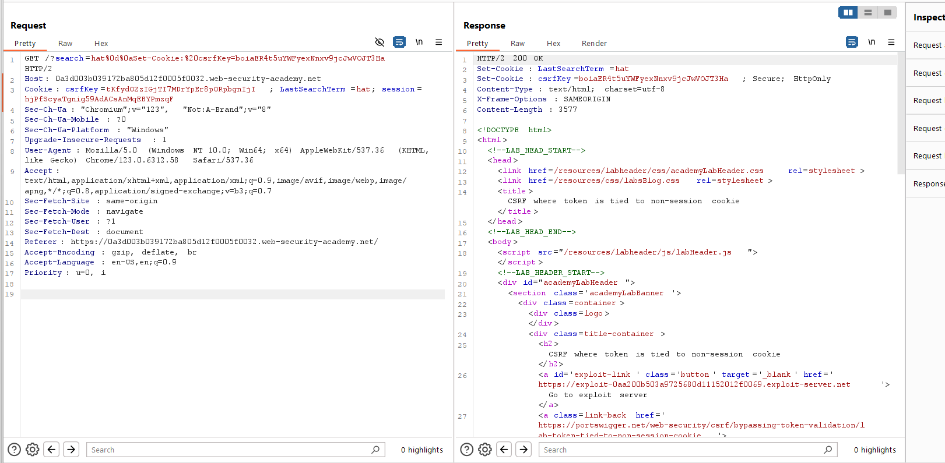
Figure 7: Search Tthe One Thing On The Home Section Of Weiner Account Lab And Send Therequest To The Repeter Ad Mdify The Header Search With Cookies Key Request
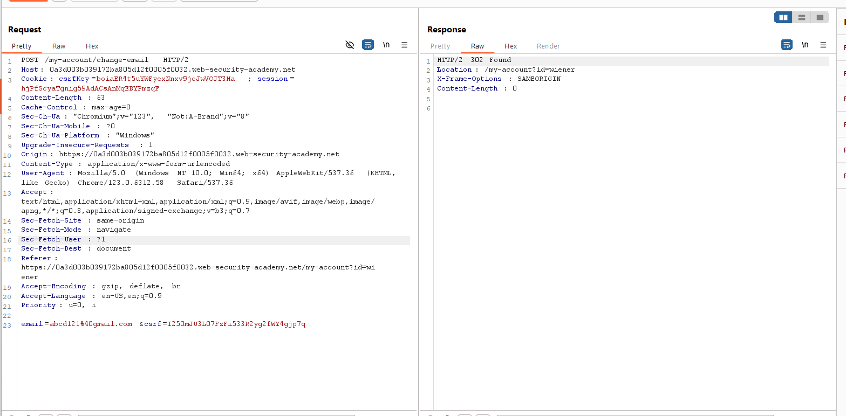
Figure 8: Sennd The Request Ofweiner Request Mail Change To Repetr And Use Tthe Carlos Csrf Key And Csrf Token

Lab Status: SOLVED

